# Emerging methods for early detection of forest fire

**Model building**

# Configuring the learning process

|  |  |
| --- | --- |
| Team ID | PNT2022TMID17141 |
| Project Name | Emerging methods for early detection of forest fire |

**Configuring the learning process**

With both the training data defined and model defined, it's time to configure the learning process. This is accomplished with a call to the compile () method of the Sequential model class. Compilation requires 3 arguments: an optimizer, a loss function, and a list of metrics.

**IMPORT LIBRARIES:**

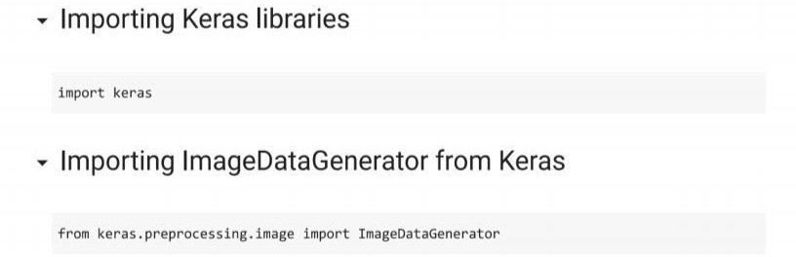

**IMPORT ImageDataGenerator FROM KERAS:**

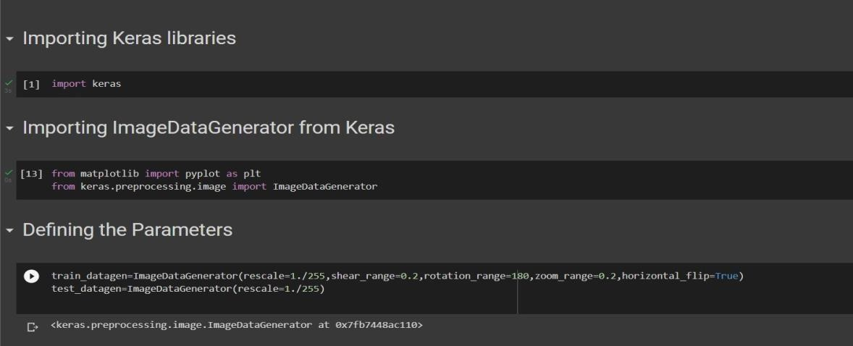

# APPLYING ImageDataGenerator to train dataset:

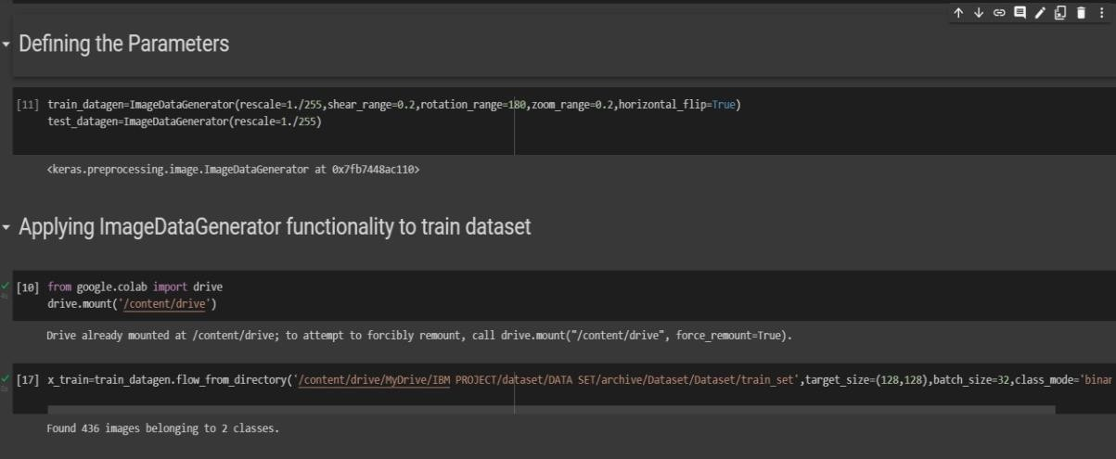ply**flow_from_directory ( )**methodfor Train folder.

# APPLYING ImageDataGenerator to test dataset:

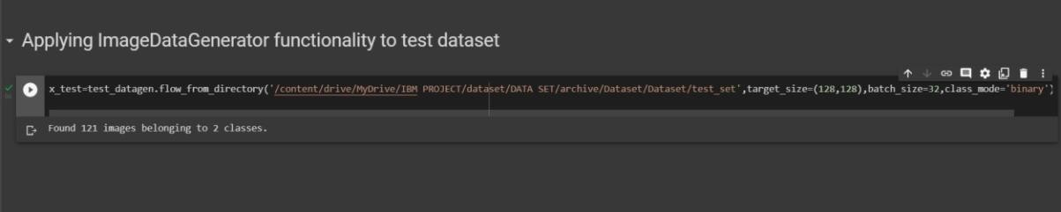Applying the **flow_from_directory ( )** methodfortest folder.

# IMPORTING MODEL BUILDING LIBRARIES:

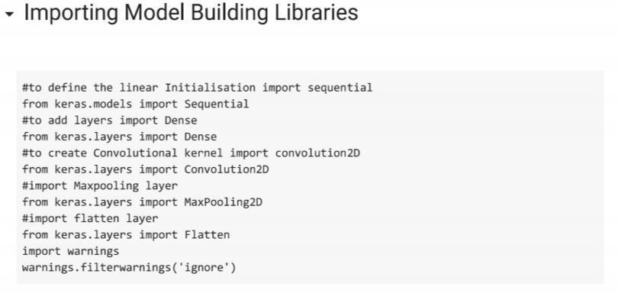

**INITIALIZING THE MODEL:**

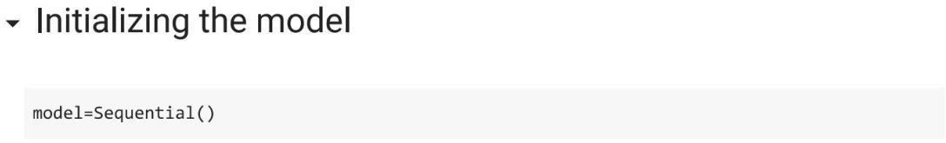

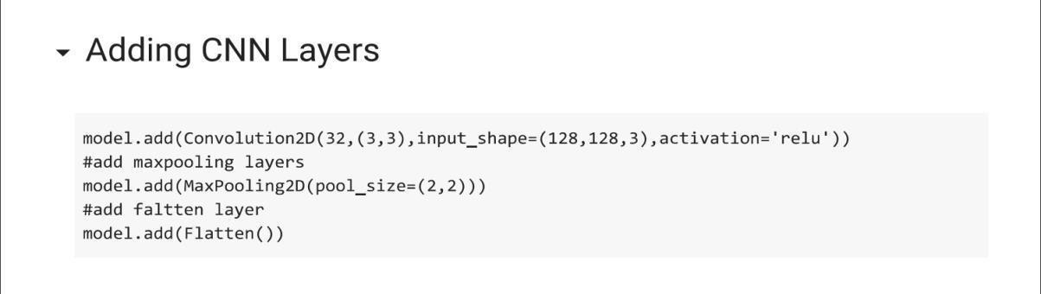**ADDING CNN LAYERS:**

**ADDING DENSE LAYERS:**

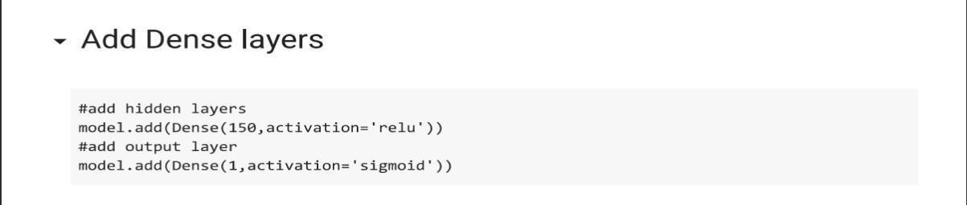

**CONFIGURING THE LEARNING PROCESS:**

